Math & Urban Planning: Worksheet #1
Page 1: Delivering the Mail

Several street maps of towns are shown. For each map, determine whether it is possible to find a route in which the mail carrier walks down every street exactly once, and begins and ends at the Post Office, marked with an X. Is it possible? State Yes or No. (You do not have to show the route on the map.)
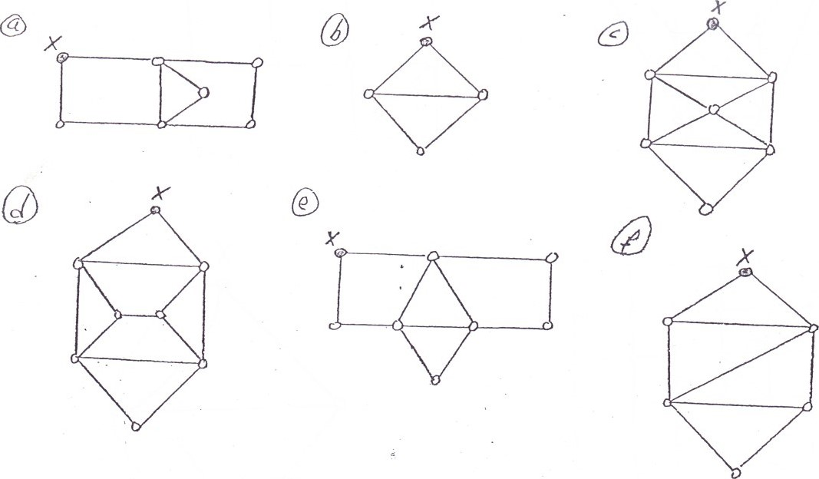
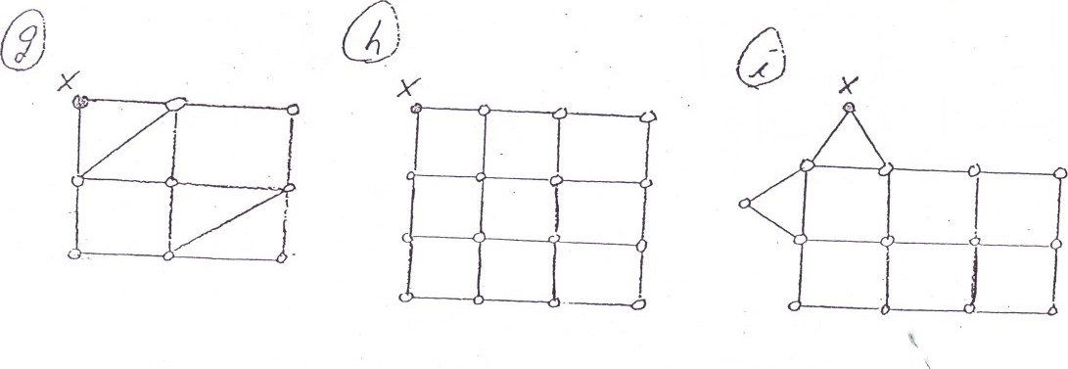

When you finish with these (or just want to move on), check out the Konigberg Bridge Problem on page 2!

Math & Urban Planning: Worksheet #1
Page 2: Konigsberg Bridge Problem

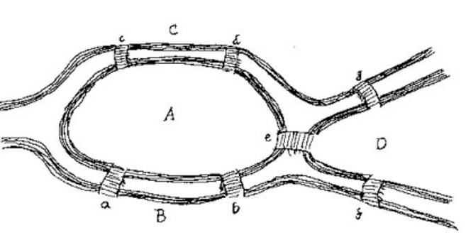
The Pregel River runs through the city of Konigsberg, with seven bridges crossing the river as shown in the map.
The citizens of Konigsberg were trying to solve a puzzle: Is possible to start anywhere, walk around the city and cross every bridge exactly once, and return to the start?
Can you find a way to do it?

